 | Mound Valley  News and Notes | Oct. 2021
______________________________________________________________________________________
Important Dates:
1 Jr. High band practice at LCHS and performance at the football game.
4 4:00 Jr. High VB @ St. Pats; 7th grade FB @ Girard @ 5:00 pm
5 3:30-7:30 Parent Teacher Conference
6 VB B tournament @ 2:00 at AGS and Haury Hall.
7 Fire Prevention Presentation; Jr High FB @ LC vs Fort Scott 5:00/6:30
8 7th and 8th field trip to Baxter Springs,
12 3:30-7:00 Parent Teacher Conference
13 JrHigh VB Tournament @ LCHS @ 1:00
14 JrHigh VB @ AGS 4:00; 5:00 8th FB @ Coffeyville
16 VB tournament at Oswego in AM; Chili Supper
21 JrHigh FB @ LCHS vs. Chanute 5:00/6:30
22 End of the Quarter
25 No School-Staff Development/Work day
26 Red Ribbon Week, 1st day of JH Wrestling
29 Fall parties-parade in the gym at 2:15; Neewollah parade
(This calendar is subject to change. Please check the Mound Valley calendar on the district website for changes and updates at usd506.org Click on the Calendar button, then choose the Mound Valley calendar. You may have to choose the current month to update the calendar.)
- Spelling Bee
Congratulations to all of our spelling bee contestants. Karlie Shearheart, Savannah Shaw, Teagan Shaw, Marleigh Dewey, Jordan Essig, Dante Ochoa, Brindley Penrod, Brock McCarty, Natalie Hoppes, Veronica Howell, Lacey Merrick, Mason Hoppes, Maddox Dewey, Madison Hoppes, Charles Black. Our winner is Madison Hoppes and our runner-up is Brindley Penrod. Great job Mustangs!
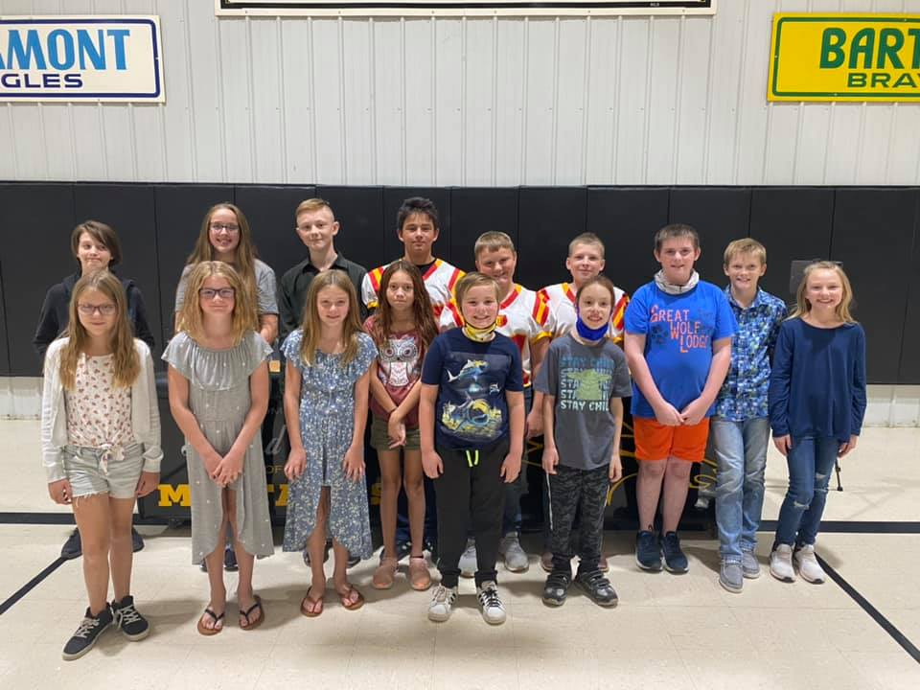

- Yearbook Team
Congratulations to our 2021-2022 Mustang Yearbook staff! Madison Hoppes, Brock McCarty, Brady Ghering, Lacey Merrick, Sami Martin, Braylynn Deweese, Makayla Farran, and Faith Winters.

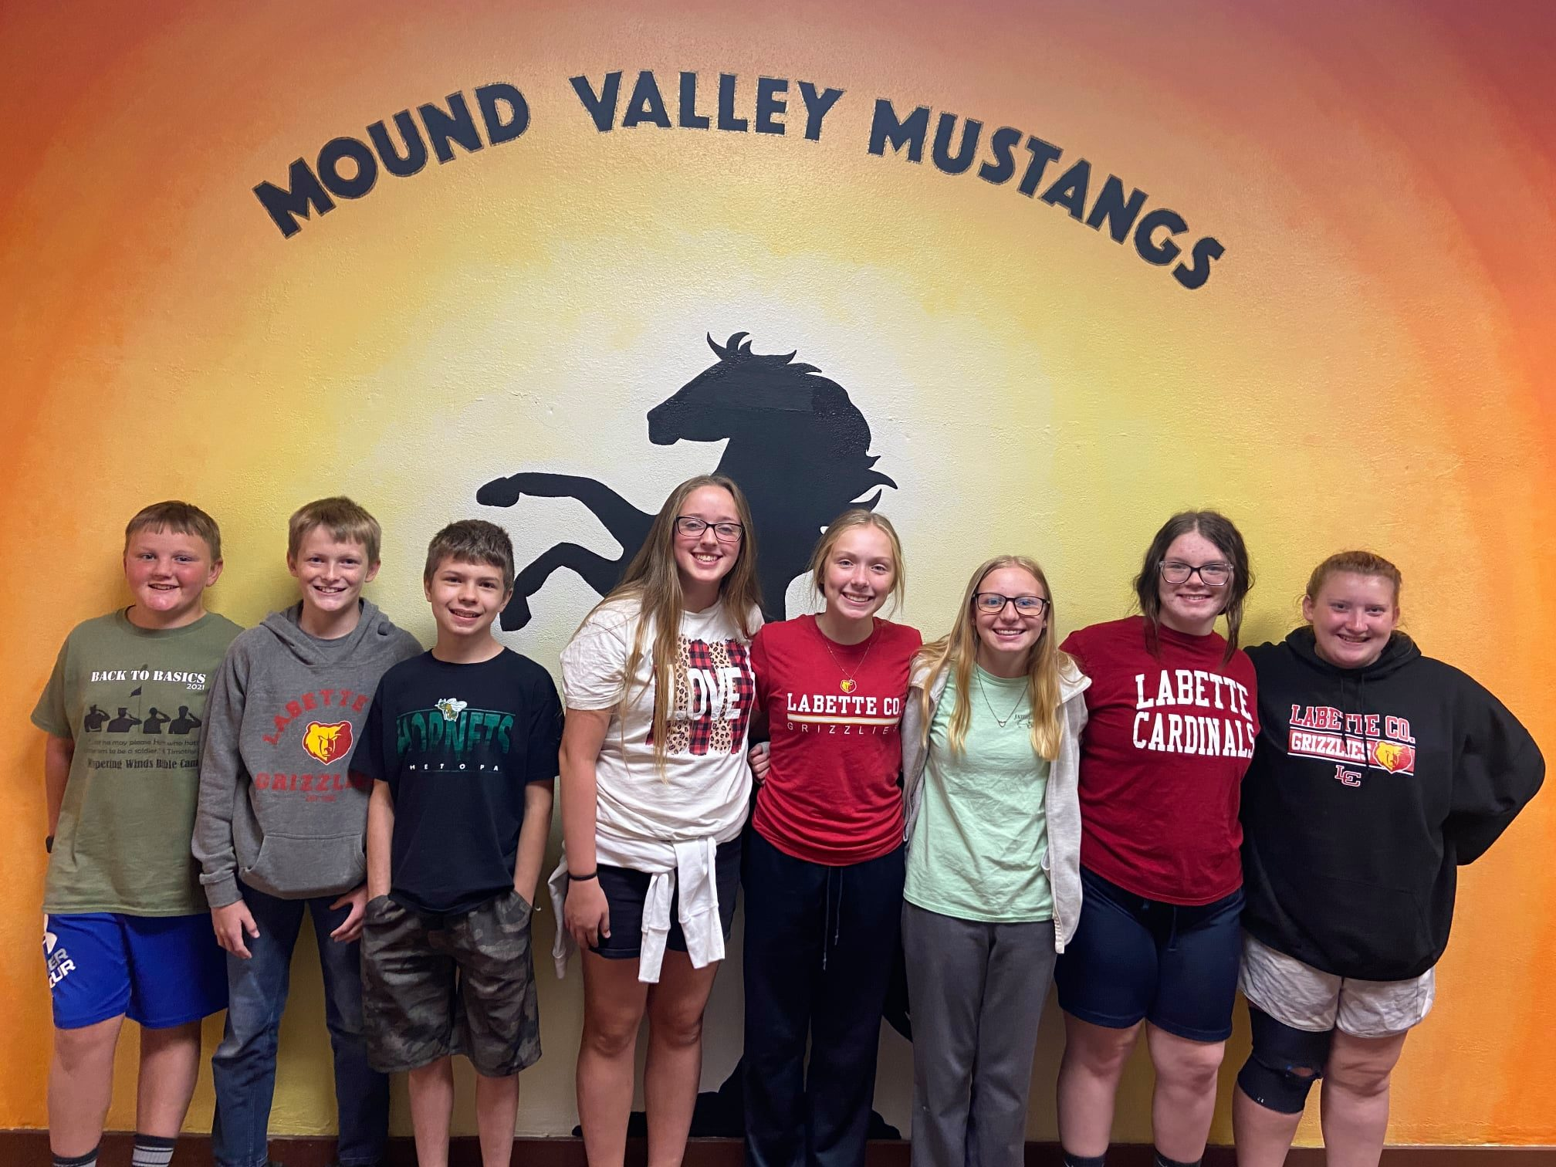

- Chili Supper
Our annual Chili Supper is on October 16, 2021. Students will be bringing home information soon.

- Fall Parties
Our Fall parties will be Friday, October 29th. Students in Grades Kindergarten - 5th grade are allowed to bring their costumes to school and change into them. Please make sure that you do not send make up and attachments to the costume that require help putting on. We would prefer that you save those for your own Fall festivities. We also ask that all costumes worn at school are appropriate for school and follow the school dress code. Student Parade in the gym will be at 2:15 and classroom party will follow.

- Parents' Right to Know
Each of the District’s five, K-8 school buildings has a KSDE approved school-wide Title I program. A school-wide program permits our schools to use funds from Title I, Part A and other Federal education program funds and resources to upgrade the entire educational program of the school in order to raise academic achievement for all the students. This contrasts with a Title I targeted assistance program, through which Title I, Part A funds are used only for supplementary educational services for eligible children who are failing or at risk of failing to meet State standards.
As a school-wide Title I program we are required, at the beginning of every school year, to tell parents they have a right to request the following information about the professional qualifications of their children’s teachers.
- Why School Breakfast?
Breakfast really is the most important meal of the day for kids, as it provides the necessary energy to get set for a day of learning and achievement. Some of the benefits of eating school breakfast include:
Higher Academic Scores- Studies have shown eating breakfast at school results in higher test scores.
Convenience & Value for Parents- School breakfast is ideal for busy families trying to get out the door quickly in the mornings. And at an average price of less than $2 per meal, it's a great value too!
- What's Cooking?
Breakfast Scramble: Can you unscramble the yummy breakfast food below? We've given you a hint to help you figure it out!
_ _ _ _ _ _ _ _ _ _ _ _ _ _
0 % 0 1 P L A P E I J E C U
HINT: This School Breakfast item is a liquid. One of this fruit, each day, keeps the doctor away. The peel of this fruit can be all shades of red, yellow, or green. This fruit is an excellent form of fiber, and is fat free, sodium free, & cholesterol free.

